TIMES NEW ROMAN, 12 PT, BOLD

Prof. Dr. xxxxxxx (ORCID: 0000-0000-0000-0000)
Xxxxx University, Faculty of Xxxxxxx, Department of Xxxxxxxxx, Balıkesir-Türkiye
Email:xxxxxx@balikesir.edu.tr
Orcid: https://orcid.org/0000-0000-0000-000X
Phone: +90xxxxxxxxx

Doç. Dr.xxxxxx (ORCID: 0000-0000-0000-0000)
Xxxxx University, Faculty of Xxxxxxx, Department of Xxxxxxxxx, Balıkesir -Türkiye
Email:xxxxxx@balikesir.edu.tr
Orcid: https://orcid.org/0000-0000-0000-000X
Phone: +90xxxxxxxxx

Özet
Bu şablonda formatının gereksinimleri anlatılmaktadır. Özet, boşluklar dahil 200-300 kelimeden oluşmalı ve ana noktaları özetlemelidir.
- Yazı tipi Times New Roman, yazı tipi boyutu 12 punto ve satır aralığı tek olmalıdır.
- Sayfa Kenar Boşlukları: Üst, alt, sol ve sağ kenar boşlukları 2,5 cm olarak ayarlanmalıdır. Paragraf aralığı eklemeyin.
- Özet metni tek bir paragraftan oluşmalıdır.
- Türk katılımcılarınç alışmalarının hem Türkçesi hem de İngilizcesi olmalıdır.
- Tüm bildiriler *.doc veya *.docx formatında yazılmalı ve web sitesinin e-posta adresine gönderilmelidir.
Anahtar Kelimeler: 3-6 kelime

Abstract
This template outlines the formatting requirements. The abstract should consist of 200–300 words, including spaces, and must summarize the main points.
• The font must be Times New Roman, with a font size of 12 points and single line spacing.
• Page Margins: Top, bottom, left, and right margins should be set to 2.5 cm. Do not add paragraph spacing.
• The abstract text must consist of a single paragraph.
• Submissions by Turkish participants must be provided in both Turkish and English.
• All papers must be prepared in *.doc or *.docx format and submitted to the email address provided on the website.
Keywords: 3-6 words

ÖNEMLİ NOT:Metnin tamamı TNR 12 punto, tek satır aralığı olacak şekilde hazırlanmalıdır. Paragraf başlarında 0.5 girinti bırakılmalıdır.Tablolar ve şekiller dikey sayfaya sığacak şekilde ortalı verilmelidir. Yatay sayfada yatay şekilde hazırlanan tablolar ve şekiller Kabul edilmeyecektir.

- Introduction
Xxxxxxxxxxxxxxxxxxxxxxxxxxxxxxxxxxxxxx. Xxxxxxxxxxxxxxxxxxxx xxx xxxxxxxxxxxxxxx. Xxxxxxxxxxxxxxxxxxxxxxxxxxxxxx. Xxxxxxxxxxxxxxxxxxxxxxxxxxxxxxxxxxxxxx. Xxxxxxxxxxxxxxxxx xxx xxxxxxxxxx xxx xxxxxxxxxx xxx xxxx. Xxxxx xxx xxxxxxxxxxxxxxxxxxxxxxxxxxxxxxxxxxxxxxxxxxxxxxxxxxx xxx xxxxxxxxxxxxxxxxxxxxxx xx xxxxxxxxxxxxxxxxxxxxxxxxxxxxxxxxxxxxx. Xxxxxxxxxxxxxxxxxxxxxxxxxxxxxx (Tol, 2002).
Xxxxxxxxxxxxxxxxxxxxxxxxxxxxxxxxxxxxxx. Xxxxxxxxxxxxxxxxxxxx xxx xxxxxxx xxx xxxxxxxxxx xxx xxxx. Xxxxxx xxx xxxxxxxxxxxxxxxxxxxxxxxxxxxxxxxxxxxxxxxxxxxxxxxxxxx xxx xxxxxxxxxxxxxxxxxxxxxxxxxxxxxxxxxxxxxxxxxxxxxxxxxxxxxxxxxxxxx. Xxxxxxxxxxxxxxxxxxxxxxxxxxxxxx (Jenkins&Joppa, 2009). Xxxxxxxxxxxxxxxxxxxxxxxxxxxxxxxxxxxxxx. Xxxxxxxxxxxxxxxxx xxx xxxxxxxxxx xxx xxxxxxxxxx xxx xxxx. Xxxxx xxx xxxxxxxxxxxxxxxxxxxxxxxxxxxxxxxxxxxxxxxxxxxxxxxxxxx xxx xxxxxxxxxxxxxxxxxxxxxx xx xxxxxxxxxxxxxxxxxxxxxxxxxxxxxxxxxxxxx. Xxxxxxxxxxxxxxxxxxxxxxxxxxxxxx (Martellozzo et al., 2018).
- Materials and Methods
Xxxxxx xxx xxxxxxxxxxxxxxxxxxxxxxxxxxxxxxxxxxxxxxxxxxxxxxxxxxx xxx xxxxxxxxxxxxxxxxxxxxxxxxxxxxxxxxxxxxxxxxxxxxxxxxxxxxxxxxxxxxx. Xxxxxxxxxxxxxxxxxxxxxxxxxxxxxx (Jenkins & Joppa, 2009). Xxxxxxxxxxxxxxxxxxxxxxxxxxxxxxxxxxxxxx. Xxxxxxxxxxxxxxxxx xxx xxxxxxxxxx xxx xxxxxxxxxx xxx xxxx. Xxxxx xxx xxxxxxxxxxxxxxxxxxxxxxxxxxxxxxxxxxxxxxxxxxxxxxxxxxx xxx xxxxxxxxxxxxxxxxxxxxxx xx xxxxxxxxxxxxxxxxxxxxxxxxxxxxxxxxxxxxx. Xxxxxxxxxxxxxxxxxxxxxxxxxxxxxx (Martellozzo et al., 2018).
- FindingsandDiscussion
AccordingtoThe Economist (2004), xxxxxxxxxxxxxxxxxxxxxxxxxxxxxxxxxxxxx. Xxxxxxxxxxxxxxxxxxxx xxx xxxxxxx xxx xxxxxxxxxx xxx xxxx.Xxxxxx xxx xxxxxxxxxxxxxxxxxxxxxxxxxxxxxxxxxxxxxxxxxxxxxxxxxxx xxx xxxxxxxxxxxxxxxxxxxxxxxxxxxxxxxxxxxxxxxxxxxxxxxxxxxxxxxxxxxxx. Xxxxxxxxxxxxxxxxxxxxxxxxxxxxxx (Jenkins&Joppa, 2009). Xxxxxxxxxx xxx xxxxxxxxxxxx (TUIK,2015).

Table 1. Urban and rural population in Türkiye (TUIK, 2015)
Year | Total Population | City / DistrictCenters |  | Towns / Villages
Year | Total Population | Population | % | Population | %
1927 | 13.648.270 | 3.305.879 | 24.2 | 10.342.391 | 75.8
1940 | 17.820.950 | 4.346.249 | 24.4 | 13.474.701 | 75.6
1950 | 20.947.188 | 5.244.337 | 25.0 | 15.702.851 | 75.0

Xxxxx xxx xxxxxxxxxxxxxxxxxxxxxxxxxxxxxxxxxxxxxxxxxxxxxxxxxxx xxx xxxxxxxxxxxxxxxxxxxxxx xx xxxxxxxxxxxxxxxxxxxxxxxxxxxxxxxxxxxxx (Dinc& Gül, 2022) (Figure 1). Xxxxxxxxxxxxxxxxxxxxxxxxxxxxxx (Martellozzo et al., 2018).
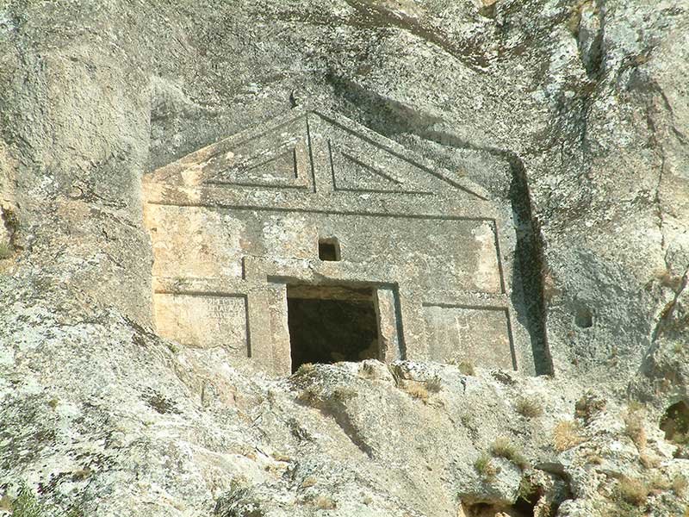
Figure 1.Rocktombs (Dinc& Gül, 2022)

Xxxxxx xxx xxxxxxxxxxxxxxxxxxxxxxxxxxxxxxxxxxxxxxxxxxxxxxxxxxx xxx xxxxxxxxxxxxxxxxxxxxxxxxxxxxxxxxxxxxxxxxxxxxxxxxxxxxxxxxxxxxx. Xxxxxxxxxxxxxxxxxxxxxxxxxxxxxx (Jenkins&Joppa, 2009). Xxxxxxxxxxxxxxxxxxxxxxxxxxxxxxxxxxxxxx. Xxxxxxxxxxxxxxxxx xxx xxxxxxxxxx xxx xxxxxxxxxx xxx xxxx. Xxxxx xxx xxxxxxxxxxxxxxxxxxxxxxxxxxxxxxxxxxxxxxxxxxxxxxxxxxx xxx xxxxxxxxxxxxxxxxxxxxxx xx xxxxxxxxxxxxxxxxxxxxxxxxxxxxxxxxxxxxx. Xxxxxxxxxxxxxxxxxxxxxxxxxxxxxx (Figure 2).

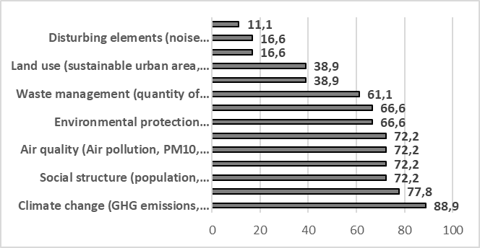
Figure 2. Frequency of use of thethemes

- ConclusionandRecommendations
Xxxxxxxxxxxxxxxxxxxxxxxxxxxxxxxxxxxxxx. Xxxxxxxxxxxxxxxxxxxx xxx xxxxxxx xxx xxxxxxxxxx xxx xxxx. Xxxxxx xxx xxxxxxxxxxxxxxxxxxxxxxxxxxxxxxxxxxxxxxxxxxxxxxxxxxx xxx xxxxxxxxxxxxxxxxxxxxxxxxxxxxxxxxxxxxxxxxxxxxxxxxxxxxxxxxxxxxx. Xxxxxxxxxxxxxxxxxxxxxxxxxxxxxx (Tol, 2002).Xxxxxxxxxxxxxxxxxxxxxxxxxxxxxxxxxxxxxx. Xxxxxxxxxxxxxxxxxxxx xxx xxxxxxx xxx xxxxxxxxxx xxx xxxx. Xxxxxx xxx xxxxxxxxxxxxxxxxxxxxxxxxxxxxxxxxxxxxxxxxxxxxxxxxxxx xxx xxxxxxxxxxxxxxxxxxxxxxxxxxxxxxxxxxxxxxxxxxxxxxxxxxxxxxxxxxxxx. Xxxxxxxxxxxxxxxxxxxxxxxxx
Xxxxxxxxxxxxxxxxxxxxxxxxxxxxxxxxxxxxxx. Xxxxxxxxxxxxxxxxx xxx xxxxxxxxxx xxx xxxxxxxxxx xxx xxxx. Xxxxx xxx xxxxxxxxxxxxxxxxxxxxxxxxxxxxxxxxxxxxxxxxxxxxxxxxxxx xxx xxxxxxxxxxxxxxxxxxxxxx xx xxxxxxxxxxxxxxxxxxxxxxxxxxxxxxxxxxxxx. Xxxxxxxxxxxxxxxxxxxxxxxxxxxxxx (Martellozzo et al., 2018). Xxxxxxxxxxxxxxxxxxxxxxxxxxxxxxxxxxxxxx. Xxxxxxxxxxxxxxxxxxxx xxx xxxxxxx xxx xxxxxxxxxx xxx xxxx. Xxxxxx xxx xxxxxxxxxxxxxxxxxxxxxxxxxxxxxxxxxxxxxxxxxxxxxxxxxxx xxx xxxxxxxxxxxxxxxxxxxxxxxxxxxxxxxxxxxxxxxxxxxxxxxxxxxxxxxxxxxxx. Xxxxxxxxxxxxxxxxxxxxxxxxx
Thanksand Information Note
Xxxxxxxxxxxxxxxxxxxxxxxxxxxxxxxxxxxxxx. Xxxxxxxxxxxxxxxxxxxx xxx xxxxxxx xxx xxxxxxxxxx xxx xxxx. Xxxxxx xxx xxxxxxxxxxxxxxxxxxxxxxxxxxxxxxxxxxxxxxxxxxxxxxxxxxx xxx xxxx.
References
Dinç, G. & Gül, A. (2022). Estimation of effectivespatialvariableswhenvisitingpublicsquaresthroughfactoranalysis model. Journal of Urban Planning and Development, 148(3), p.25-36. 04022022. https://doi.org/10.1061/(ASCE)UP.1943-5444.0000844
Jenkins, C. N. &Joppa, L. (2009). Expansion of the global terrestrialprotectedareasystem. BiologicalConservation, 142: 2166–2174. DOI: 10.1016/j.biocon.2009.04.016.
Martellozzo, F., Amato, F., Murgante, B. & Clarke, K. C. (2018). Modelingtheimpact of urban growth on agricultureandnaturalland in Italyto 2030. AppliedGeography,91, 156-167.
The Economist. (2004). The Rise of the Green Building, Accessed on 10 Dec 2017, available online at: http://economist.com/PrinterFriendly.cfm?Story_ID=3422965
Tol, R. (2002). Estimates of thedamagecosts of climatechange. Environmentaland Resource Economics, 21(2), 135-160.
Turkish Statistical Institute (TUIK). (2015). Urban andRuralPopulation Data in Turkey. Access Address (12.12.2019): http://tuik.gov.tr/

