APP-1 Internship Report Cover Page



T.R.
BALIKESİR UNIVERSITY
FACULTY OF FINE ARTS

(Times New Roman, Bold, 18 pt Font)

Internship Report

(Times New Roman, Bold, 22 pt Font)

Student’s
Name and Surname :
ID Number: (Times New Roman, Bold, 16 pt Font)
Department:

BALIKESİR
APP-2 Department Internship Committee Student Internship Evaluation Form

T.R.
BALIKESİR UNIVERSITY
FACULTY OF FINE ARTS
DEPARTMENT OF ………………………………
INTERNSHIP EVALUATION FORM

STUDENT’S
Name‒Surname : ……………………………………………….……………….
ID Number : ……………………………………………….……………….
Department : ……………………………………………….……………….

EVALUATION | SCORE
INSTITUTION/ORGANIZATION EVALUATION^{a, b} (1‒5 SCORE)
EVALUATION OF THE INTERNSHIP EVALUATION COMMISSION OF THE DEPARTMENT (1‒5 SCORE)
ªVery Good (5), Good (4), Satisfactory (3), Poor (2) and Very Poor (1)
^{b}Evaluate the institution/organization in which the student completed his/her internship and the Programme Internship Coordinator, the results of the internship evaluation report is successful if it is above or equal to 3 (each one) out of 5.

SUCCESSFUL | UNSUCCESSFUL
If UNSUCCESSFULL, the reason is ….........……………………………………………………………………
………………………………………………………………………………………………………………………………...

EVALUATION DATE …… /….. /…..

DEPARTMENT INTERNSHIP COMMISSION
Chairman:
Name‒Surname : .................................................................
Title : .................................................................
Signature : .................................................................

Member: Member:
Name‒Surname : ...................................................... Name‒Surname : ...............................................................
Title : ...................................................... Title : ..............................................................
Signature : ...................................................... Signature : ..............................................................

NOTE: This form will be filled by the Intership Commission of the Department

APP-3 Internship Report Inner Cover Page
T.R.
BALIKESİR UNIVERSITY
FACULTY OF FINE ARTS
INTERNSHIP REPORT INNER COVER PAGE

STUDENT’S;
Photo
Name‒Surname : ………………………………………
ID Number : ………………………………………
Department : ………………………………………
Registration Year : ………………………………………

INSTITUTION/ORGANIZATION;

Name : ……………………………………………………..
Address : ……………………………………………………..
Phone : ……………………………………………………..
Fax : ……………………………………………………..
E-mail : ……………………………………………………..
Internship Start Date : ……………………………………………………..
Internship End Date : ……………………………………………………..

INSTITUTION/ORGANIZATION AUTHORIZED PERSON FOR INTERNSHIP;

Signature-Seal : …………………………………………………………….
Title : …………………………………………………………….
Name‒Surname : …………………………………………………………….

APP-4 Sample Training Report Page

TRAINING REPORT PAGE
THE NAME OF THE DEPARTMENT WORKED AS INTERN: …………………………………………………
DATE: …./…../………..
APPROVAL OF THE AUTHORIZED PERSON FOR INTERNSHIP: …………………………………………..
SIGNATURE, COMPANY STAMP/SEAL : …………………………………………..
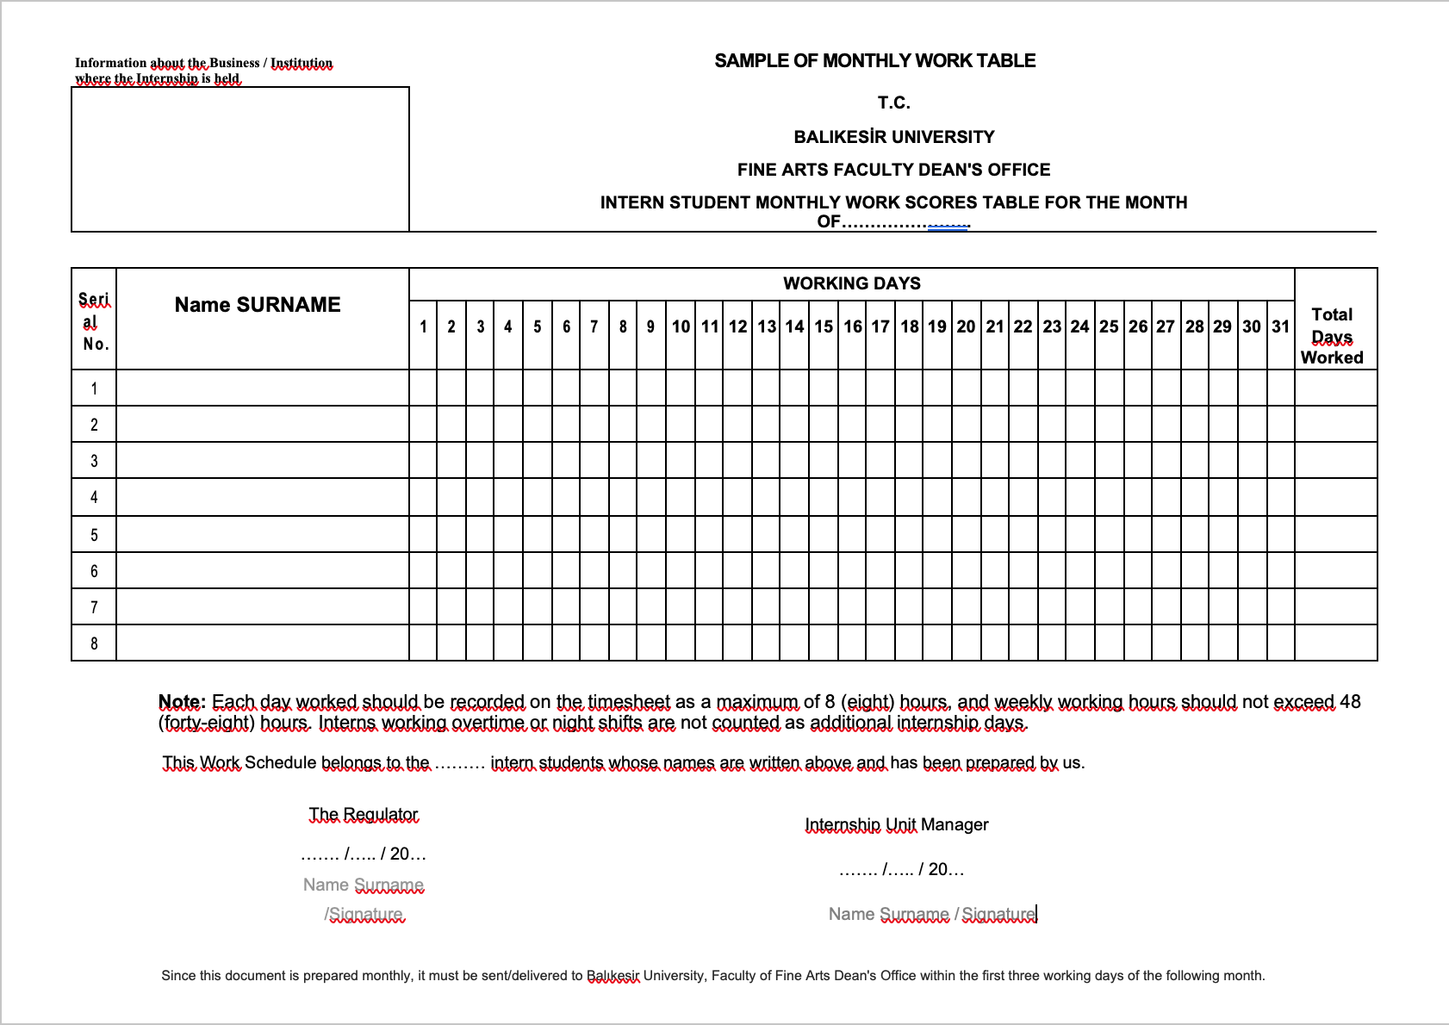
NOTE:1- This contract will be prepared in 3 (three) copies, one copy will remain in the Faculty Social Security Institution Internship Office, one copy will remain with the student and the other copy will remain with the Business.
ANNEX 9. Business Internship Completion Certificate
T.R.
BALIKESİR UNIVERSITY
TO THE DEAN OF THE FACULTY OF FINE ARTS,

One of the students of your faculty, numbered ………………………………………, did an internship at our company ……………………………………… between the dates ……/.… / 201…- ……/ …… / 20… for …… days.

I respectfully submit and request your information.

……/……/……
Authorized Person's Name-Surname
Title-Stamp
Business Title
Address:
Phone:
E-mail:

